**Duplication & Typecasting**

Instructions:

Please share your answers filled inline in the word document. Submit Python code and R code files wherever applicable.

Please ensure you update all the details:

**Name: N.Harsha vardhan_**

**Batch Id: nharsha569103528**

**Topic: Preliminaries for Data Analysis**

**Problem statement:**

Data collected may have duplicate entries, that might be because the data collected were not at regular intervals or for any other reason. Building a proper solution on such data will be a tough ask. The common techniques are either removing duplicates completely or substituting those values with logical data. There are various techniques to treat these types of problems.

Q1. For the given dataset perform the type casting (convert the datatypes, ex. float to int)

Q2. Check for duplicate values, and handle the duplicate values (ex. drop)

Q3. Do the data analysis (EDA)?

Such as histogram, boxplot, scatterplot, etc.

|  |  |  |  |  |  |  |  |
| --- | --- | --- | --- | --- | --- | --- | --- |
| InvoiceNo | StockCode | Description | Quantity | InvoiceDate | UnitPrice | CustomerID | Country |
| 536365 | 85123A | WHITE HANGING HEART T-LIGHT HOLDER | 6 | 12/1/2010 8:26 | 2.55 | 17850 | United Kingdom |
| 536365 | 71053 | WHITE METAL LANTERN | 6 | 12/1/2010 8:26 | 3.39 | 17850 | United Kingdom |
| 536365 | 84406B | CREAM CUPID HEARTS COAT HANGER | 8 | 12/1/2010 8:26 | 2.75 | 17850 | United Kingdom |
| 536365 | 84029G | KNITTED UNION FLAG HOT WATER BOTTLE | 6 | 12/1/2010 8:26 | 3.39 | 17850 | United Kingdom |
| 536365 | 84029E | RED WOOLLY HOTTIE WHITE HEART. | 6 | 12/1/2010 8:26 | 3.39 | 17850 | United Kingdom |
| 536365 | 22752 | SET 7 BABUSHKA NESTING BOXES | 2 | 12/1/2010 8:26 | 7.65 | 17850 | United Kingdom |
| 536365 | 21730 | GLASS STAR FROSTED T-LIGHT HOLDER | 6 | 12/1/2010 8:26 | 4.25 | 17850 | United Kingdom |
| 536366 | 22633 | HAND WARMER UNION JACK | 6 | 12/1/2010 8:28 | 1.85 | 17850 | United Kingdom |
| 536366 | 22632 | HAND WARMER RED POLKA DOT | 6 | 12/1/2010 8:28 | 1.85 | 17850 | United Kingdom |

**Hints:**

For each assignment, the solution should be submitted in the below format.

1. Work on each feature of the dataset to create a data dictionary as displayed in the below image:

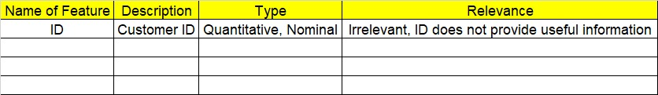

1. Consider the OnlineRetail.csv dataset.
2. Research and perform all possible steps for obtaining the solution.
3. All the codes (executable programs) should execute without errors.
4. Code modularization should be followed.
5. Each line of code should have comments explaining the logic and why you are using that function.